VCS2-VR71

Own proposal

Hugo Leenen

2018

Inhoud

The assignment 1

Methods 1

The product 2

Conclusion 2

Hour registration 2

# The assignment

I want to create a virtual environment were the user is able to view and control different trade routes between islands. The purpose is to create different means of interaction for instance the user should be able to give a ship a name so texts needs to be put in. When you are in Vr there needs to be special solution because it is not easy to access a keyboard. This project is about trying out different input methods in Vr.

# Methods

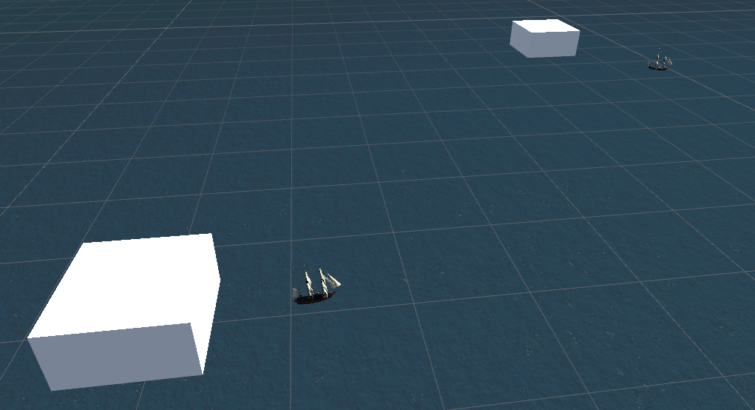I started the project by realizing a basic prototype were a user can observe the different ships going from island to island. Very simple the ships randomly sail to an island and when they are there they go to another random island.

When I realized this I started with the Vr navigation aspect of the application as a Vr user you need to be able to zoom out and zoom in. A trick I learned was when you zoom out stand in a different place and zoom in this is eliminates the need for teleporting which I thought to be really nice.

# The product

# Conclusion

# Hour registration

|  |  |
| --- | --- |
| Activities | Hours |
| Started working on a prototype were boats go from one island to the next. | 7 |
| Experimented with different ways of moving around. | 3 |
| Learned about UI elements in Vr. | 6 |
| Documentation | 2 |
|  | Total: |
|  |  |